

Semester 1 (Unit 1) Examination, 2015

Question/Answer Booklet

Rossmoyne Senior High School

MATHEMATICS METHODS

Section One: Calculator-free

Student Name/Number: ______________________________________________

Teacher Name: ______________________________________________

Time allowed for this section
Reading time before commencing work: five minutes
Working time for this section: fifty minutes

Materials required/recommended for this section
To be provided by the supervisor: This Question/Answer Booklet
Formula Sheet

To be provided by the candidate:
Standard items: pens (blue/black preferred), pencils (including coloured), sharpener, correction fluid/tape, eraser, ruler, highlighters
Special items: nil

Important note to candidates
No other items may be taken into the examination room. It is your responsibility to ensure that you do not have any unauthorised notes or other items of a non-personal nature in the examination room. If you have any unauthorised material with you, hand it to the supervisor before reading any further.

Structure of this paper

Section | Number of questions available | Number of questions to be answered | Working time (minutes) | Marks available | Percentage of exam
Section One: Calculator-free | 7 | 7 | 50 | 60 | 40
Section Two: Calculator-assumed | 11 | 11 | 90 | 90 | 60
 |  |  |  |  | 100

Instructions to candidates

- The rules for the conduct of School exams are detailed in the _______________________________________School/College assessment policy. Sitting this examination implies that you agree to abide by these rules.

- Write your answers in this Question/Answer Booklet.

3. You must be careful to confine your responses to the specific questions asked and to follow any instructions that are specific to a particular question.

- Spare pages are included at the end of this booklet. They can be used for planning your responses and/or as additional space if required to continue an answer.
  - Planning: If you use the spare pages for planning, indicate this clearly at the top of the page.
  - Continuing an answer: If you need to use the space to continue an answer, indicate in the original answer space where the answer is continued, i.e. give the page number. Fill in the number of the question that you are continuing to answer at the top of the page.

- Show all working clearly. Your working should be in sufficient detail to allow your answers to be checked readily and for marks to be awarded for reasoning. Incorrect answers given without supporting reasoning cannot be allocated any marks. For any question or part question worth more than two marks, valid working or justification is required to receive full marks. If you repeat any question, ensure that you cancel the answer you do not wish to have marked.

- It is recommended that you do not use pencil, except in diagrams.

- The Formula Sheet is not to be handed in with your Question/Answer Booklet.

Section One: Calculator-free (60 Marks) Weighting 35%

This section has 7 (seven) questions. Answer all questions. Write your answers in the spaces provided.

Suggested working time: 50 minutes.

Question 1 (7 marks)

The diagram below shows a unit circle with angle and as marked.

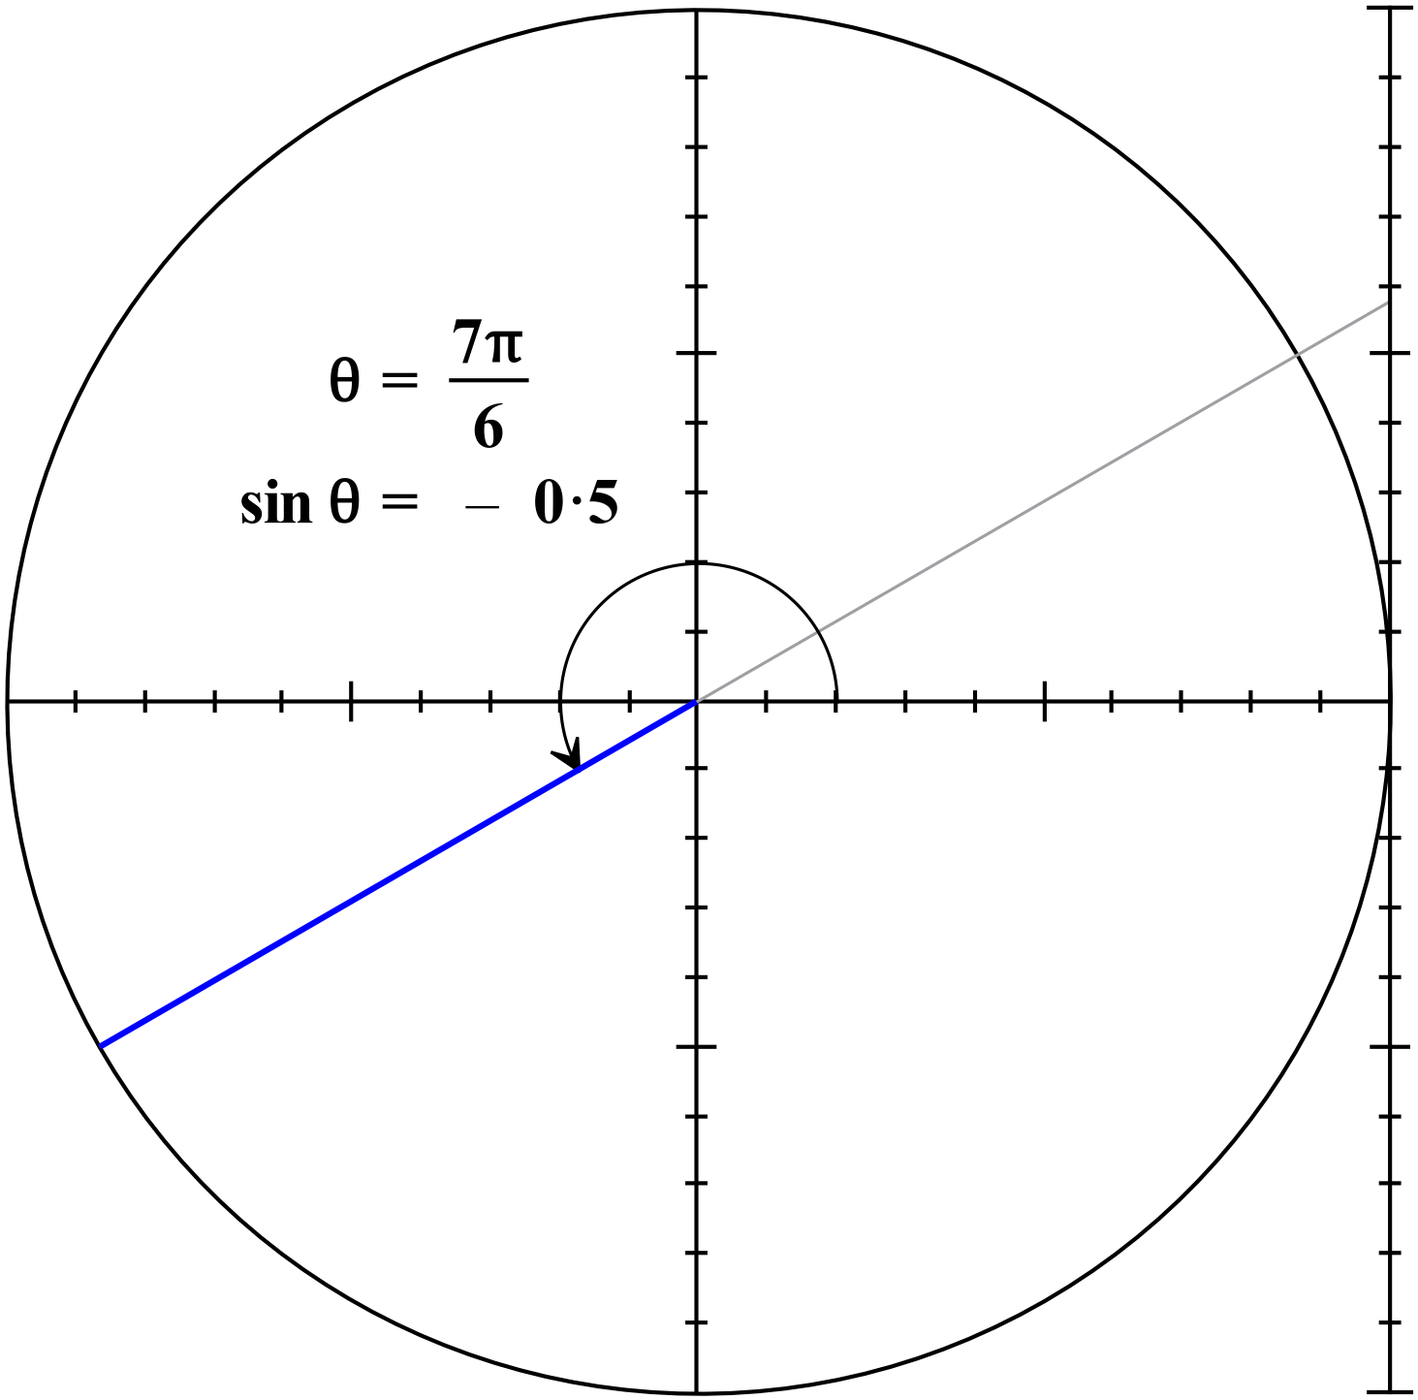

(a) State the value of in degrees. (1 mark)

(b) State exact values for . (4 marks)

(c) Given , determine the value(s) for . (2 marks)

Question 2 (9 marks)

Solve the following equations (exact answers)
(a) 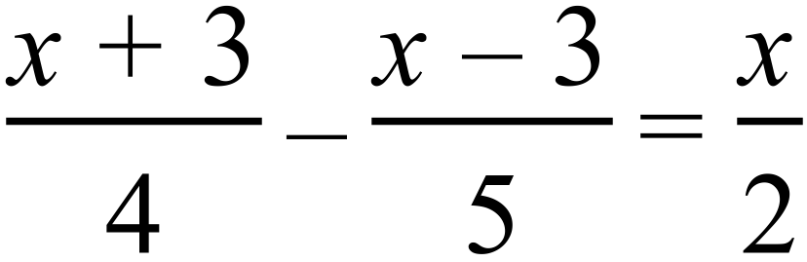 (Hint- use lowest common denominator) (3 marks)

(b) 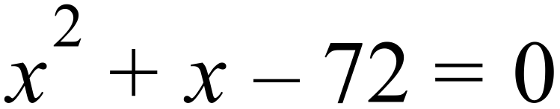 (2 marks)

(c) 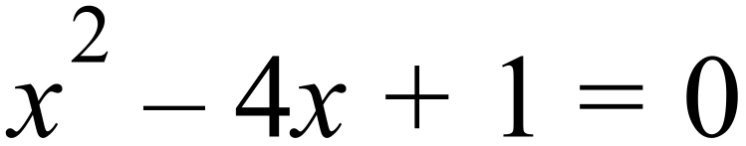 (by completing the square) (4 marks)

Question 3 (7 marks)

Sketch the following on the axes below showing clearly all key features.

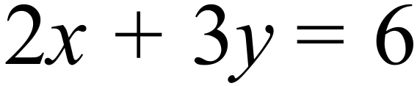 , 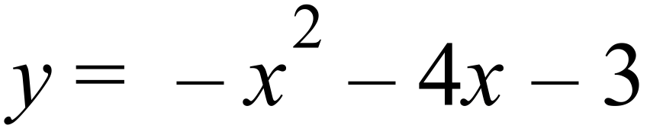 , 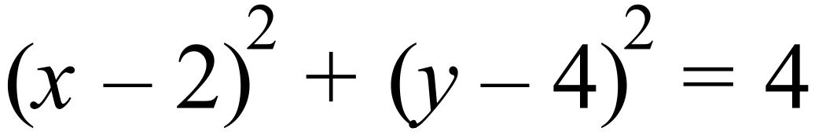

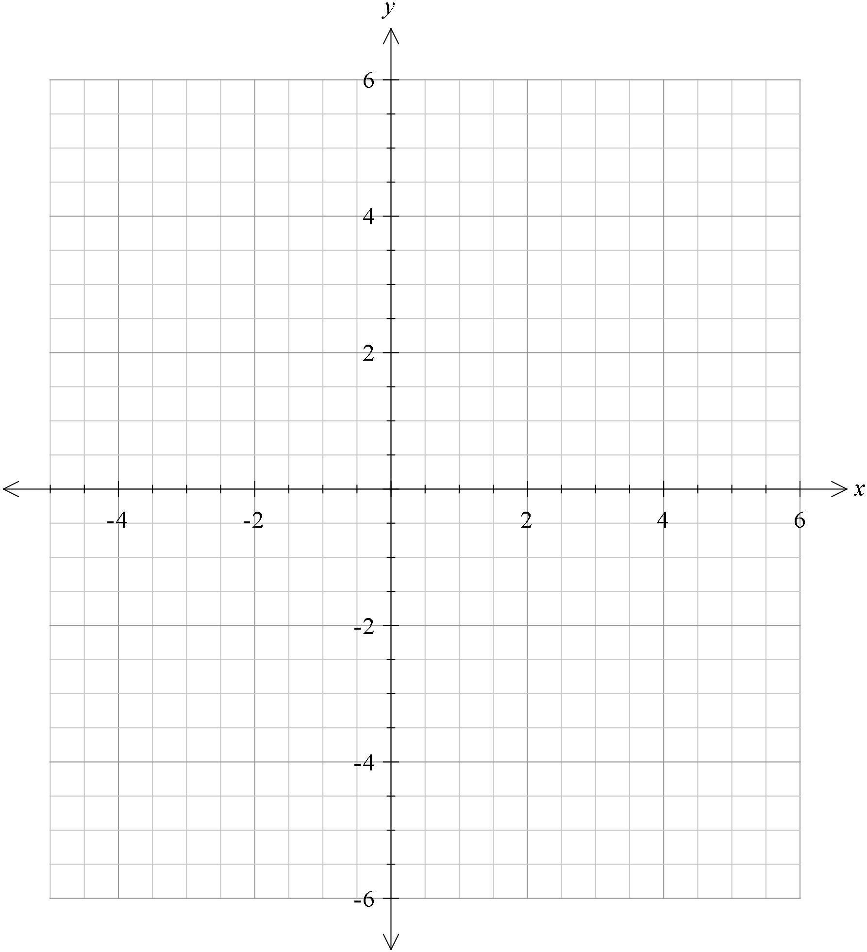

Question 4 (5 marks)

Determine the equation of each of the graphs, shown below.

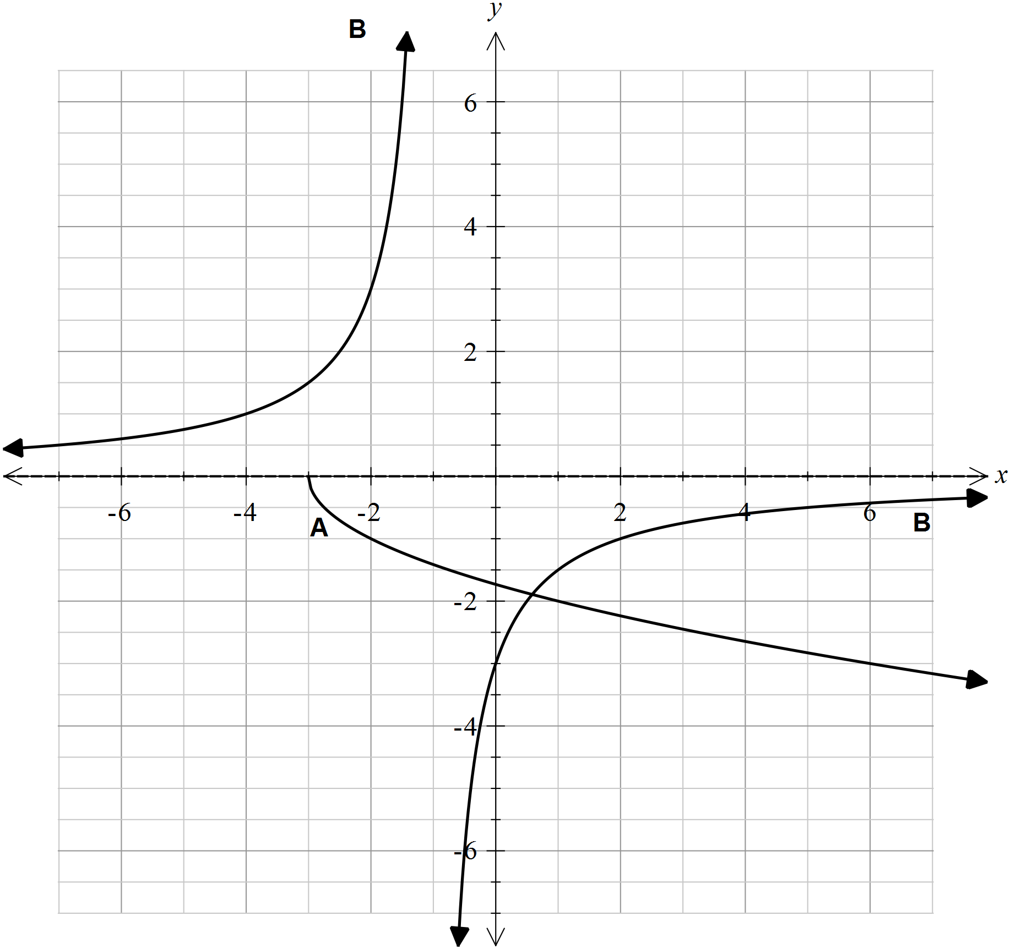

A: (2 marks)

B: (3 marks)

Question 5 (11 marks)

The Venn diagram below represents the probability sample space for two random events.

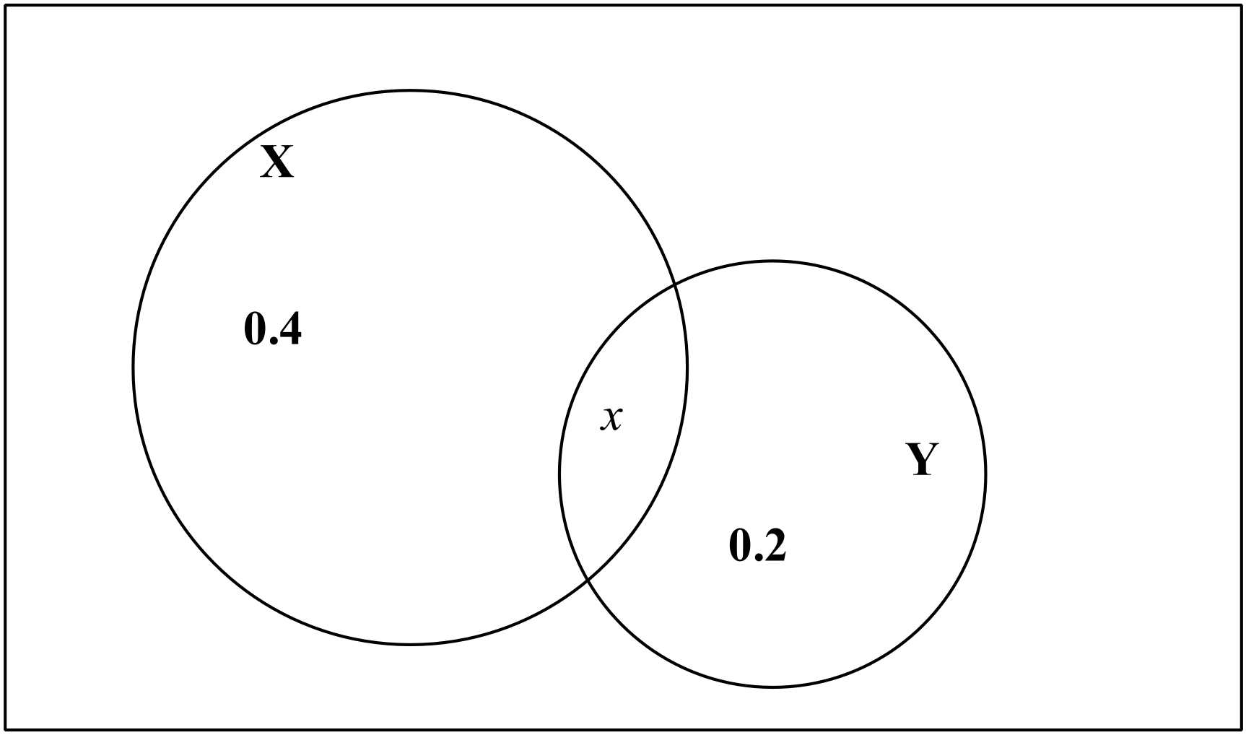

- If ,
(i) calculate . (2 marks)

(ii) Does ? Justify your answer. (3 marks)

Now let us consider,
- If , calculate
- (4 marks)

(ii) (2 marks)

Question 6 (9 marks)

(a) State the equation of the graph drawn below (4 marks)
Hint- graph of form
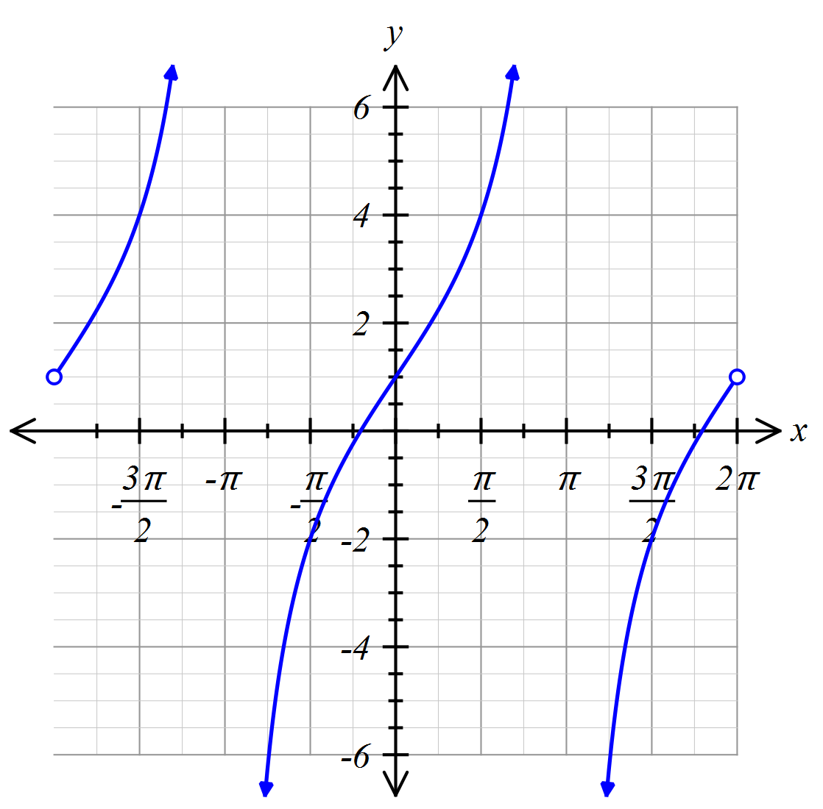

(b) On the axes below, sketch the graph of
(5 marks)

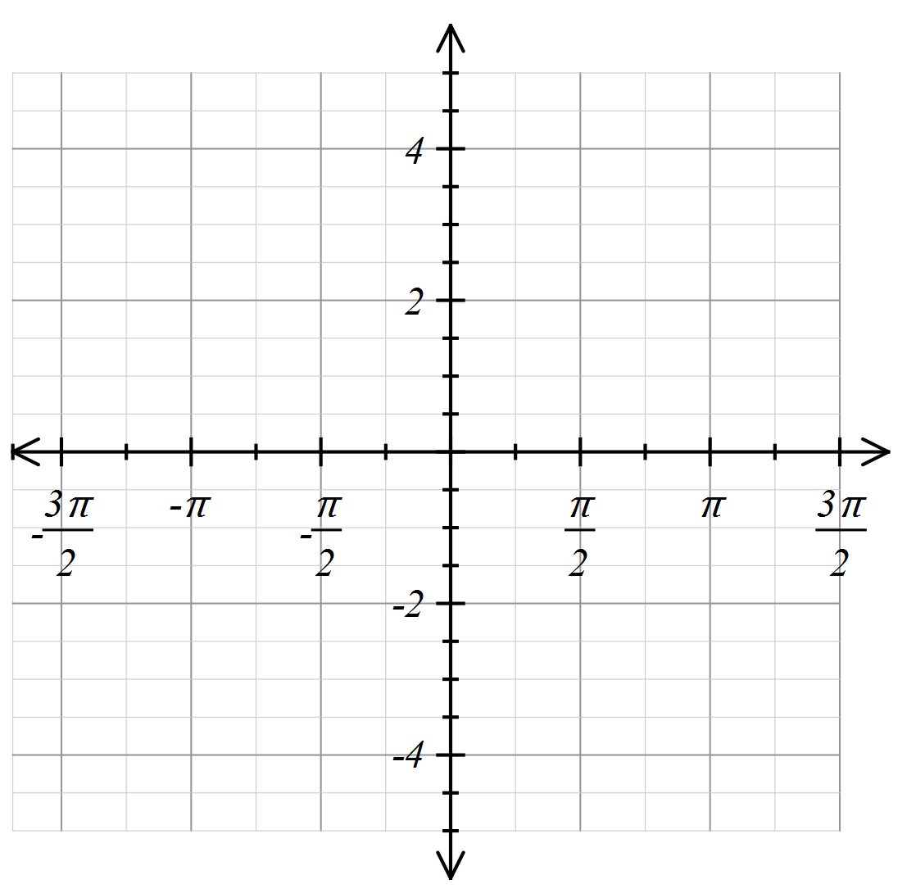

Question 7 (12 marks)

A bag contains 10 marbles: 7 red and 3 green. Two marbles are randomly selected from the bag, one after the other, the first marble not being replaced before the second is selected.

Determine the probability that the two marbles are

(a) red and green in that order, (2 marks)

(b) red and green in any order, (3 marks)

(c) of the same colour, (3 marks)

(d) two reds given they are of the same colour, (4 marks)

End of Questions

Additional working space
Question number: __________________

Acknowledgements

© MAWA, 2015
This examination is Copyright but may be freely used within the school that purchases this licence.
- The items that are contained in this examination are to be used solely in the school for which they are purchased.
- They are not to be shared in any manner with a school which has not purchased their own licence.
- The items and the solutions/marking keys are to be kept confidentially and not copied or made available to anyone who is not a teacher at the school. Teachers may give feedback to students in the form of showing them how the work is marked but students are not to retain a copy of the paper or the marking guide until the agreed release date stipulated in the purchasing agreement/licence.

